Using Event tracking will update the customers’ last activity date. The Event Wizard must be used for event tracking.
MobileStaff (MobileCirc) App Instructions – Tablet Use
- Charge all devices before your event
- Wifi is required for MobileStaff use
- Tap the MobileCirc icon from the screen
- At the Sign In page, type the Username and Password used to login to WorkFlows.
(ex. OKCCIRC/CIRC) and click Sign In.
- Tap the 3 horizontal lines in the top left corner to display all Wizard menus
- Select the Event Wizard tab from the menu on the left
If you don’t see the Event wizard tab, select Setup tab and under the Event menu put a checkmark in “Enable Event Attendance”
- Event ID: Enter your branch event id and select Start.
We are no longer using generic branch event ids. Communico events are imported into workflows. If you need help locating your specific event id in workflows refer to the bottom of this document.
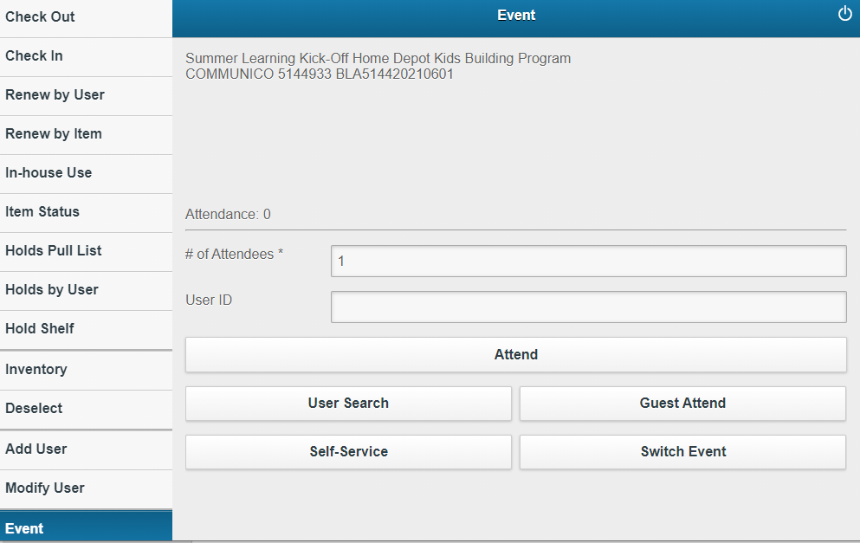
- # of Attendees – Select the appropriate # from the drop down menu for a family group using one barcode.
- User ID – Customer’s barcode may be scanned or keyed in. Once entered tap the Attend bar.
A pop-up box will appear for the first user you login – this will happen for every event for the first user. Simply enter OR to override. The pop-up says “Item may not by circulated”.
- User Search – You may use this to search for a customer’s account by name, birthdate or alt ID. The customer’s name will appear below the search field. Click on the name and the user will automatically be added to the Attendance number and you will be back on the Event page.
- Guest Attend – Tapping Guest Attend will automatically increase the Attendance #. This may be used for users that do not have a library account.
To enter your branch guest login, go to Setup (in the Wizard menu) > Event > Enter your branch guest login in the Event Guest User field.
- Self-service – This option may be used at a self-service station (computers w/barcode readers) that will allow customers to check-in without staff assistance. They may scan their barcode or select the Guest Attend tab.
To exit self-service, tap the very small, curved arrow in the top left corner of the device. The password to exit self-service is CIRC and tap OK.
- Switch Event – is used to switch your event. The event you are currently logged into is displayed at the top left corner. If it’s incorrect or you have another event, use the Switch Event option to change.
- If the account is expired, a “Privilege has expired” message pops up. Attendance will not be added for expired accounts. You may open the Wizard menu and select Modify User to update the account and then return to Event….or consider other options depending on the circumstances.

Keyboard tip: If your tablet loses its keyboard once you turn on the Bluetooth scanner, go to:
Settings > General management > Physical keyboard > Show on-screen keyboard, make sure it’s turned on!

To find your event id in workflows:
- Do an F2 Item Search for your branch event.
- Click on your event
- Click the Call Number/Item tab, it will list the associated event id(s) aka item ids. If it is a reoccurring event, multiple item ids will be listed. Click on an item id and look in the extended information section at “Event End” date to be sure you have the correct event id – in the example in the image below the event id is MOO514620210614 and is scheduled to end on June 14th 2021 at 11. (Another quick way to tell is last 7 digits of the item id will be the program date YYYYMMDD – see highlighted section above)

