Lifecycle of Communico Events in Workflows & Discovery Tools (Enterprise, PLS Connects)
- Event titles and associated event date records are automatically downloaded nightly from Communico run through some scripting to format the data to match workflow requirements including mapping Communico data fields to appropriate catalog and item fields. The file is then imported into Symphony around 10:30 via a report. This report also updates rescheduled or cancelled events (private Events are also harvested but shadowed in Symphony – be sure to use event tracker to take attendance at these types of events also so your attendance data is added into Savannah and our monthly circ reports). Below are snippets of the bibliographic data and item record of an event.
Bibliographic Data
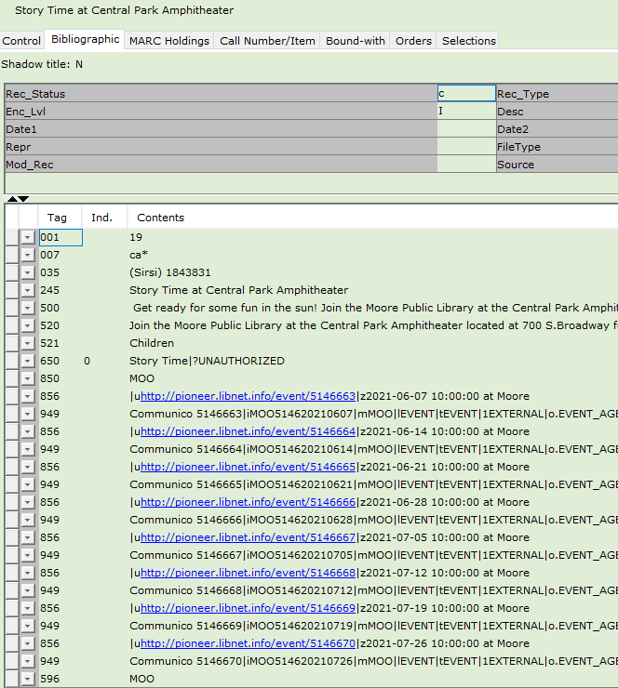
Item Info
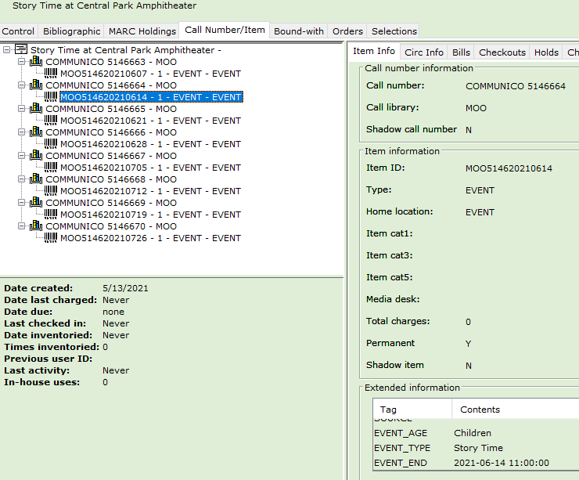
- Enterprise performs a harvest of Symphony at 4:15 am so the new/updated records appear in this discovery tool. The PLS Connect app makes web services calls live to workflows so it returns live data.
Note: the app returns a summary of the event and does not include the 856 tag that links directly to the event in Communico. Since Enterprise includes the entire Marc record it will have a link to the specific Communico event page. Below are examples of an event record from Enterprise and PLS Connect
Enterprise Record 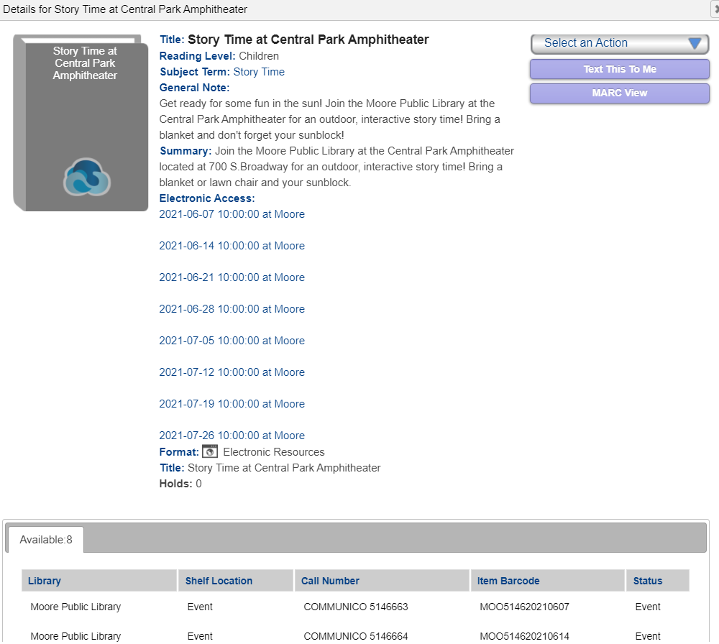

PLS Connect Record
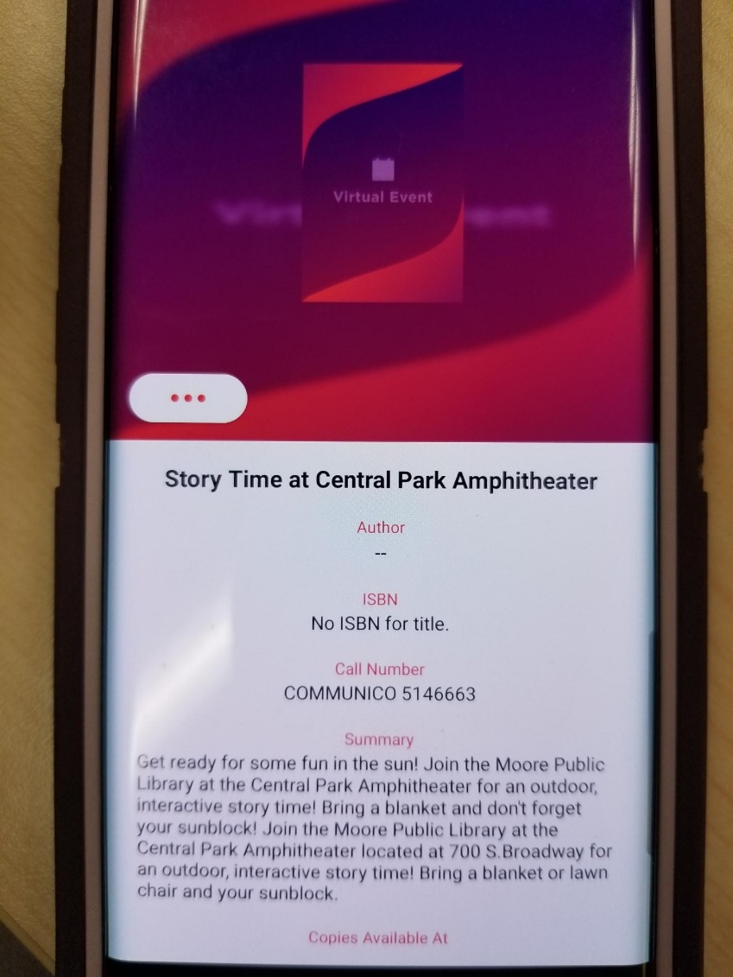
- On the third of the month event catalog & item records that took place during the prior month are set to discard and purged from the catalog between 9:30 and 10 pm

Other Notes of Interest
- Both virtual and in person event records appear in the catalog as well as those virtual events added by catalogers such as virtual museum tours
- All Events whether virtual or in person have the shelf location of EVENT
- Item library is the library hosting the event or for virtual events -- PLS if the record came from Communico or PSC if the record was added to workflows by catalogers
- In person or virtual events coming from Communico will have a call number starting with COMMUNICO. Virtual events added by catalogers will have a call number of VIRTUAL EVENT
- You can use facets in Enterprise to filter for events, try doing an open search
  - Narrow by shelf location & select EVENT
  - You can also narrow by subject and/or library

