Open Waveview Point Software
User is Security Mobile 1
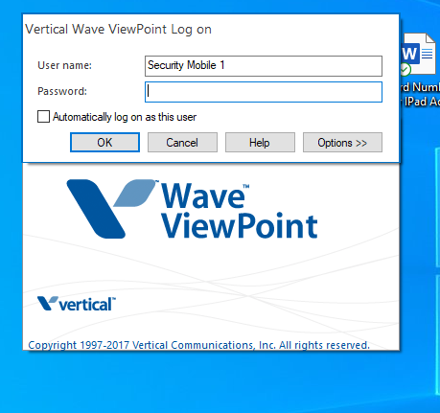
Password is 1103
Selection Options at the bottom of the password box
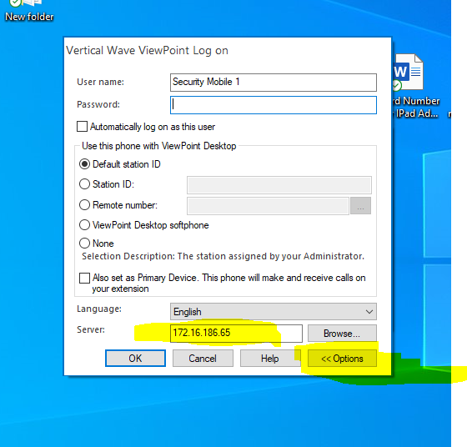
You will see the above box when you select options. In the server box put this number with periods.
172.16.186.65
This is only needed for the first time someone logs into the computer and opens Verticalwave Point.
Click OK

The program might open to messages or some other tab. So change the tab to be configuration.

Select Routing List on Left Side
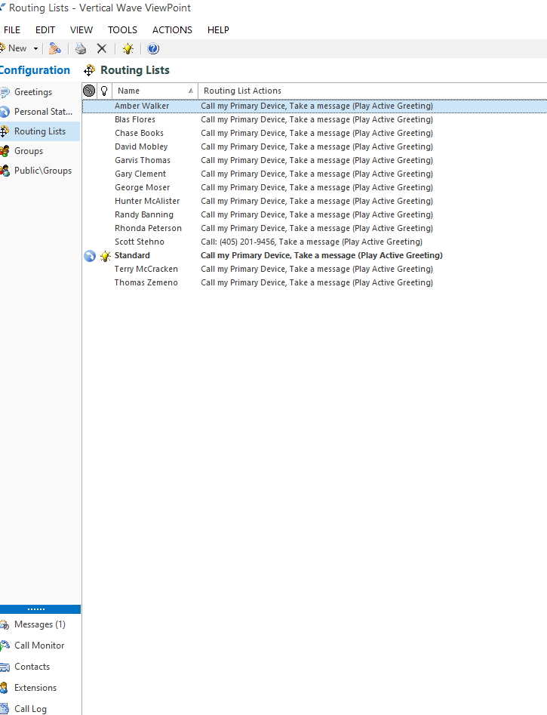
(Then Double Click their Name)
Select or click on Call my Primary Device and then select edit action (Highlighted in Yellow)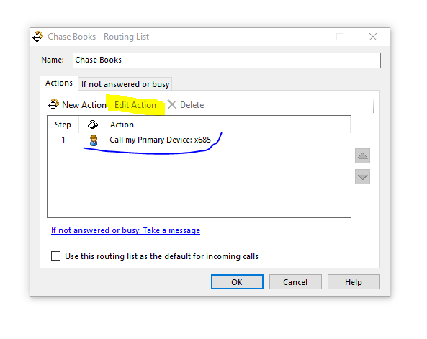
You need to change the Call Primary Device (It has a Drop Down Box for you to Select Call Another Location)
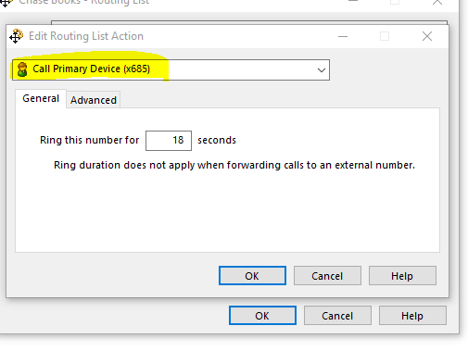
Call Another Location and add their phone number in the box highlighted in yellow

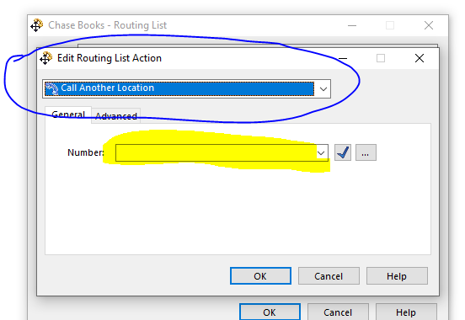
(Click OK twice)

Next Step Select Personal Status on Left side then Select New
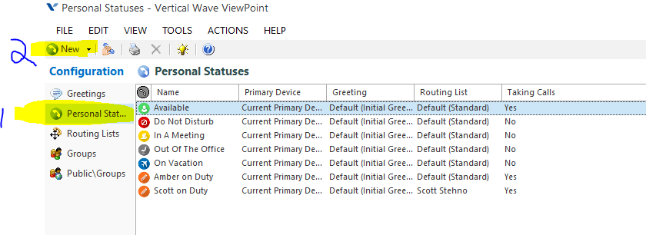
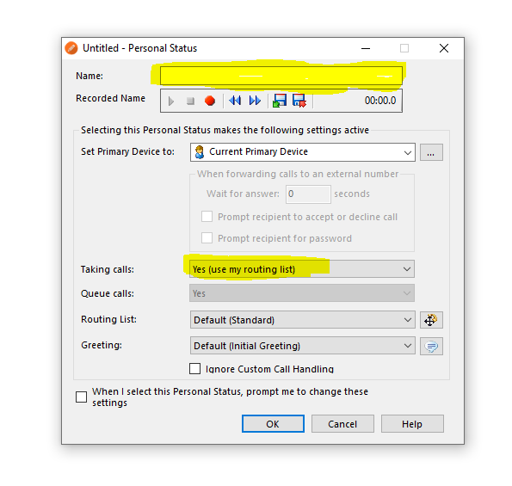
Type in Their First Name on Duty In highlighted box (Check that Taking Calls is set to Yes) Then change the Routing List to use Their Name Click (OK)
This is an example
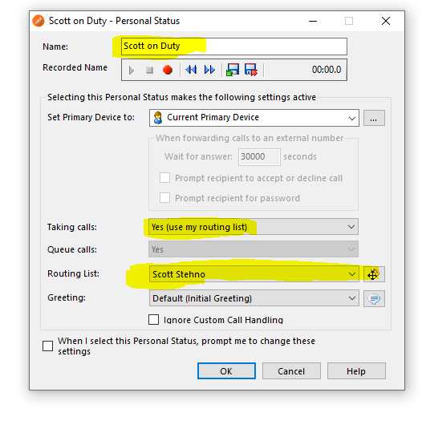

To start a shift, they need to set their status as activate. This is done by (Right Click Their Name in the Personal Status) Then selecting (Set As Activate) It can be checked by looking at bottom right corner of the screen.

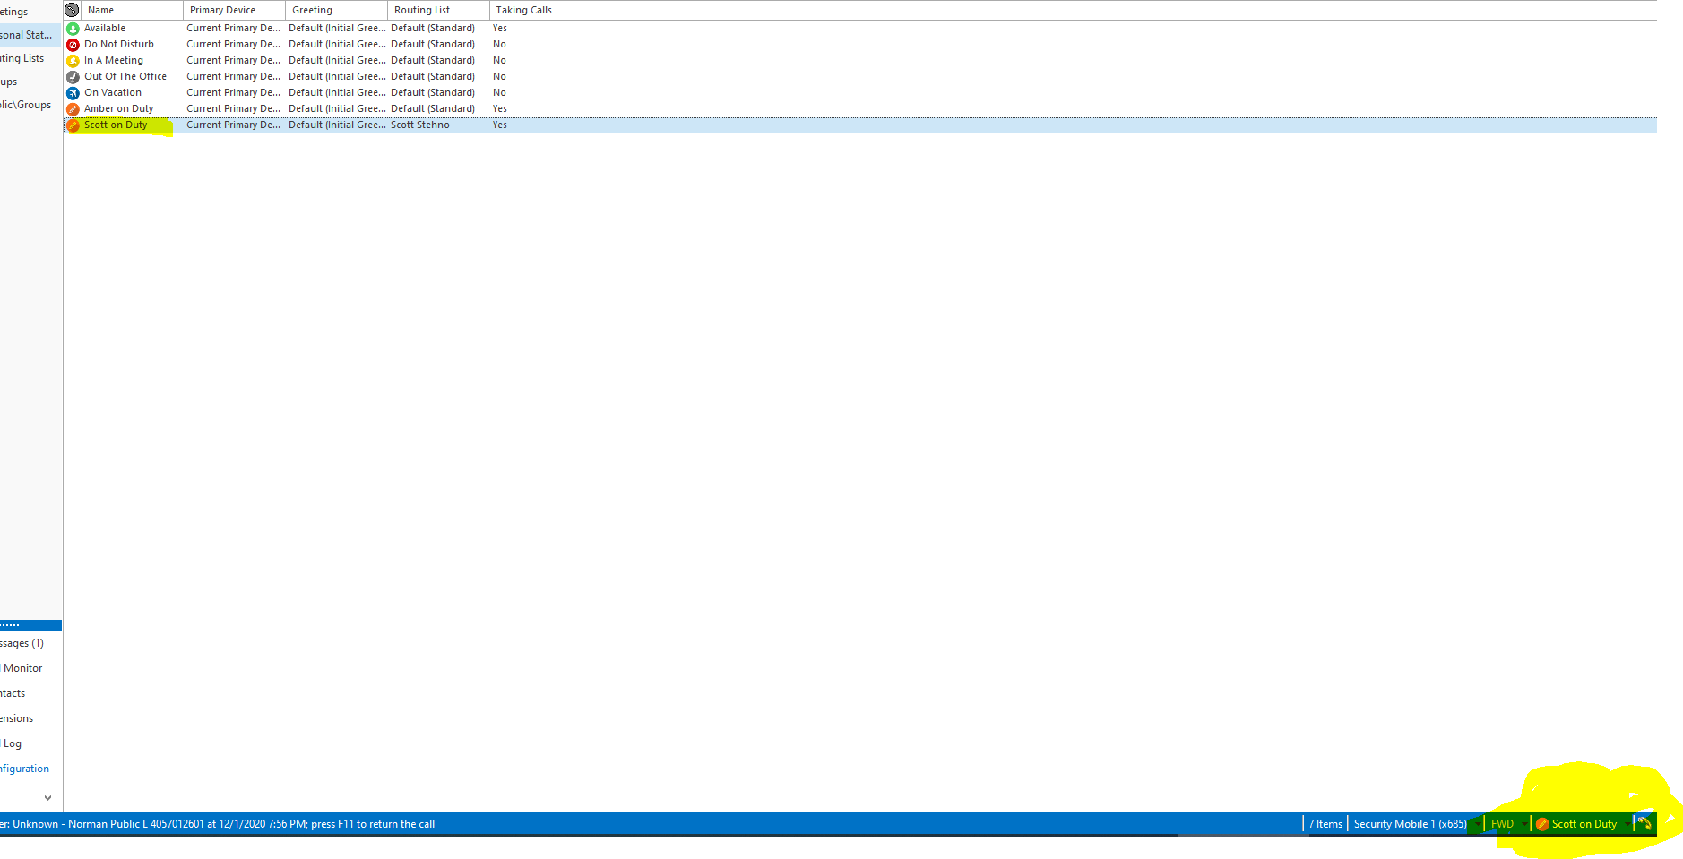

When staff call 685 it will ring the activate person’s cell phone number.

