Connect an iOS device to ClickShare in Lowry Board Room – Norman Central
***NOTE – Due to security reasons once you are connected to the ClickShare devices network you will be unable to access other Wi-Fi networks. Meaning, unless your iOS device has cellular capability, you will be unable to access the internet while Screen Mirroring.

- On your iOS device navigate to: Settings -> Wi-Fi -> Lowry-306
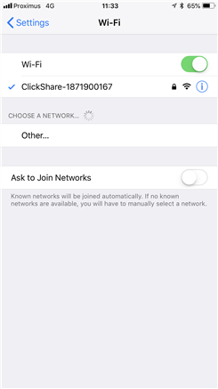
- When prompted for the password enter: clickshare
- Once connected locate the Screen Mirroring option on your device and select the Lowry Room. (See images below)
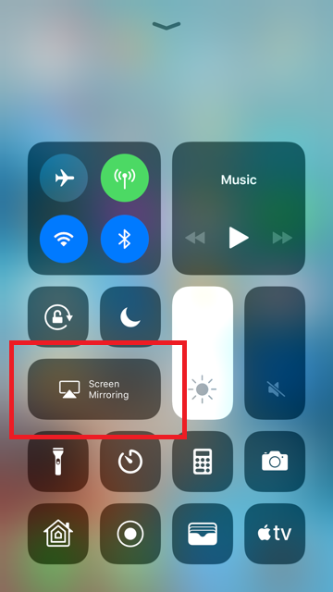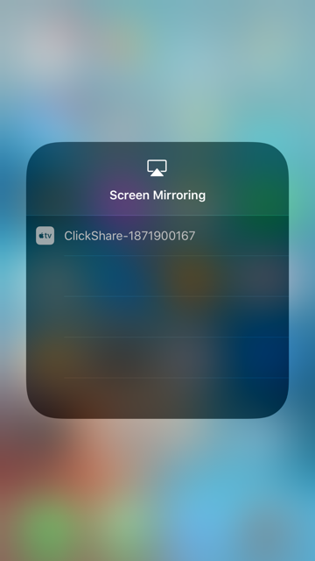

- Enter the pin that will display on one of the TVs in the room. Your screen should now be mirrored on the ClickShare displays.

