We have completed the prep work for your MobileCirc. You can register/authorize and install the MobileCirc application using the attached Installation Guide.  When starting the app, apply the Activation URL and Key listed below.  A QR code is provided below so you can scan the key onto your device if you wish.

Please create a case for customer support with any issues related to the MobileCirc so we can track the issues.  Let me know once you have attended the training and verify that you have started using MobileCirc.

Url link - <https://mobilecirc.bc.sirsidynix.net/mobilecirc>

MobileCirc License Key - 3d898bc8-d968-4c49-95e8-aec6f5d004e1

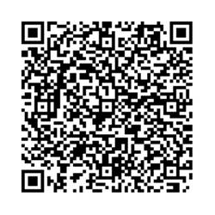

You can download the app from Apple store or Play Store for Androids.

Please see the instructions below and let me know if you have any questions.

<https://mobilecirc.bc.sirsidynix.net/mobilecirc>

1. Open Internet Explorer (recommended browser).

2. Copy and past the URL above into the address bar.

3. If you are prompted for a Key, copy and paste the MobileCirc License Key - **3d898bc8-d968-4c49-95e8-aec6f5d004e1**

4. Click Apply.

5. Select the appropriate Institution.

6. On the Sign In page, type the Username and Password that you use for normal circulation functions in your ILS (ex. NORCIRC/CIRC) and click Sign In

**Keyboard tip: If your tablet loses its keyboard once you turn on the Bluetooth scanner, go to:**

**Settings > General management > Physical keyboard > Show on-screen keyboard, make sure it’s turned on!**