How to connect to workflows using a hotspot
- Start by powering on the hotspot by holding down button on the right-hand side.

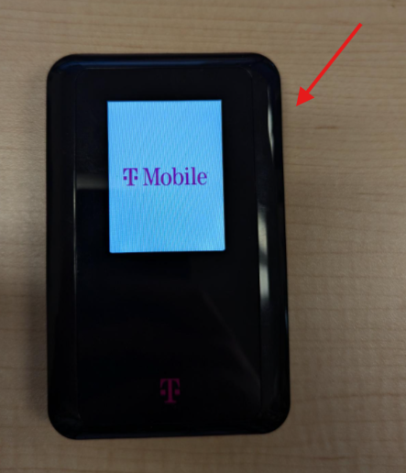

- Once on, click the power button once to see the hotspot’s password.

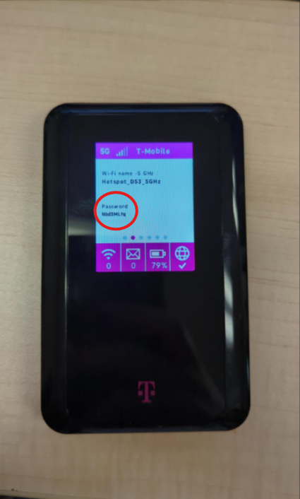
- On your laptop navigate to the bottom right corner and click on the internet globe. There you should see the hotspot listed as a network to connect to.
Be sure to select the hotspot network that ends in 5GHz

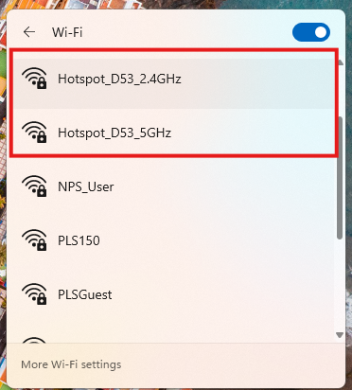

- Once you have entered the required password for the hotspot open WorkFlows and login with your respective branch credentials.
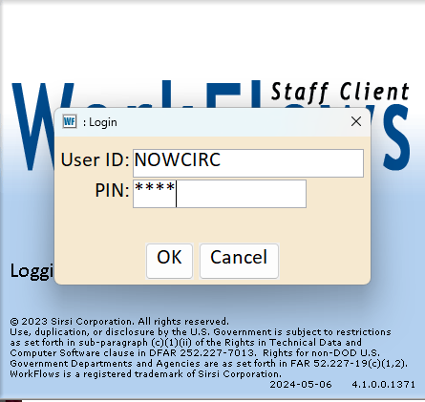
- From there you will now be able to access and use WorkFlows as needed!

