Printing a PDF with Foxit PDF Reader
To print a PDF file from Foxit PDF Reader, first save your original file in an easy to find spot, such as the desktop. To do this in Acrobat Reader, select the Menu option in the upper left, then Save As:
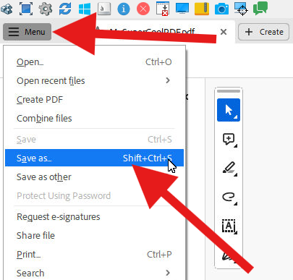
When prompted, select Choose a different folder:
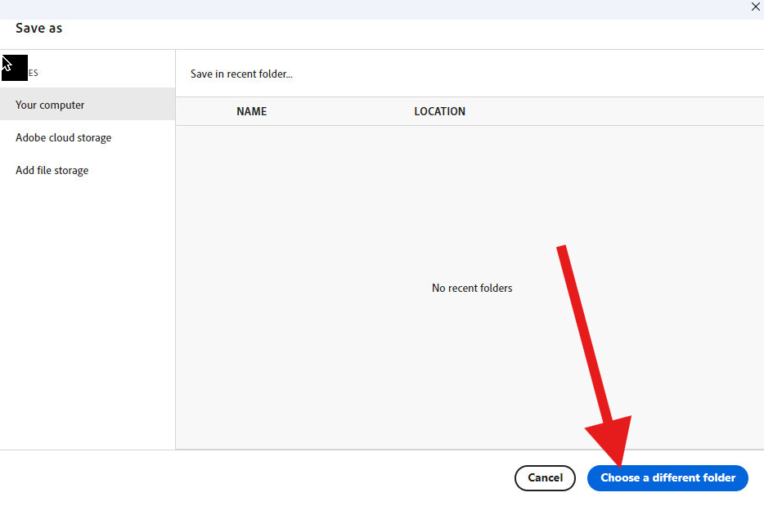
In the next menu, select Desktop in the left pane, enter a name for your file in File Name: field, then select Save.
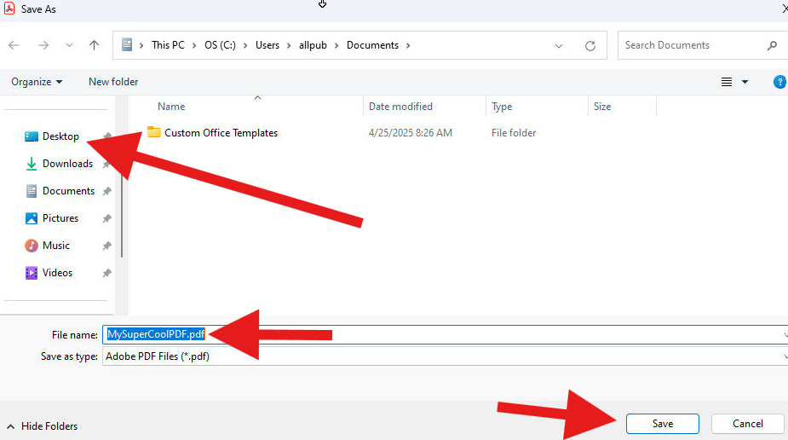
Next, locate your file on the desktop, or in the location to which it was saved in the previous step:
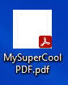

Right-click the file with the mouse, and select Open With -> Foxit PDF Reader from the menu:
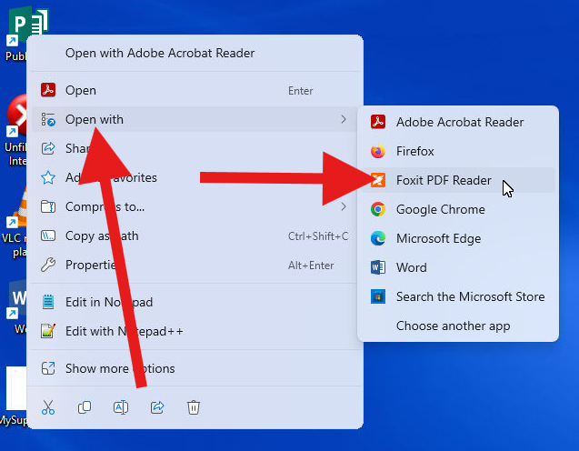
When the file loads, select the File menu in Foxit PDF Reader, and then Print:
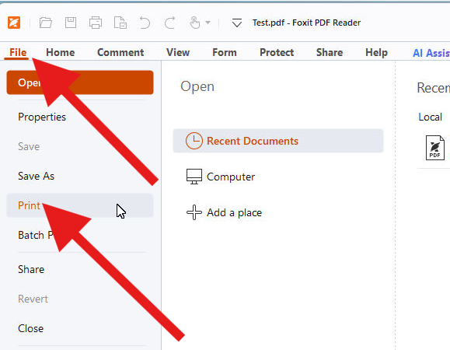
Choose your desired print options and print the file. It will be available to print at the print release station as usual.

